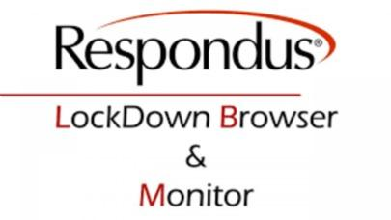

# Using Respondus Lockdown Browser on Chromebook through VDI (Virtual Desktop)

The following steps will assist you in obtaining safe and secured access to Coast Virtual Desktop (VDI) using Horizon Client software. At this time, this is the best choice for users with a Coast provided Chromebook or when other methods do not work. The Respondus Lockdown Browser and Monitor system is installed and ready for use within Coast VDI (Virtual Desktops).

## Preliminary Preparation Tips for Students

### Set One-Time Passcode (OTP) Preference to ‘Phone’ or ‘Mobile Authenticator’ instead of ‘Email’.

To access OTP Passcode Settings:

1. Using Chrome or Firefox, go to the district portal page at <https://mycoast.cccd.edu>
2. Log in using your Coast Username and Password. Your Coast username will be the portion of your Coast student email address before the @ symbol. For example, “JStudent266@student.cccd.edu” will have a username of JStudent266. Your password will be the same password used for Canvas or when accessing Virtual Desktops.
3. Once in MyCoast, in the upper right, click on arrow next to your name and click **My Account**
4. Click **Password Recovery and Verification Methods with One-Time Passcodes**

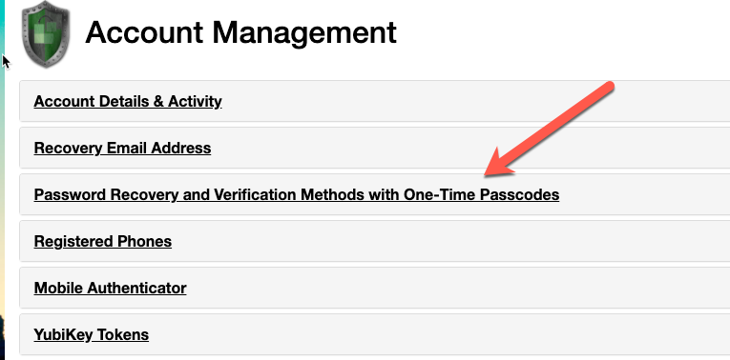

1. Ensure that **Website Login** method is at Phone or Mobile Authenticator and not Email  
     
     
   NOTICE: If ‘Phone’ is not a selectable option, you must first add a phone using the ‘Registered Phones’ menu option as shown below.  
   
2. Once Phone (or Mobile Authenticator) has been selected and confirmed, click **Log Out** in the upper right corner.  
   

## Sign into the Chromebook

1. If this is Coast provided Chromebook, no login is required as you should be automatically logged in on boot. *Some devices may require you to login with your Coast username and password.*
2. Once logged in to your Chromebook, you should see the VM Horizon Virtual Desktop at the bottom of the screen.



1. If you do not see this green Horizon Client icon, you may need to download the Horizon Client for Chromebook from this URL: <https://chrome.google.com/webstore/detail/vmware-horizon-client-for/ppkfnjlimknmjoaemnpidmdlfchhehel?hl=en>

## 

## 

## Boot up Horizon Remote Desktop

1. Click on the green Horizon Virtual Desktop icon

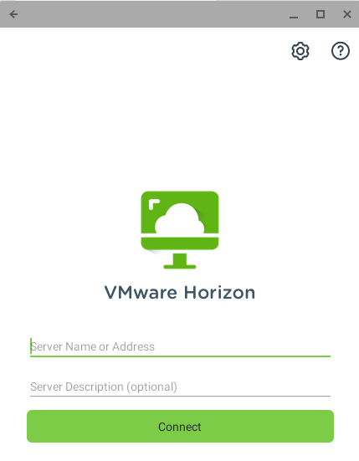

3. For Server Name, enter [https://mydesktop.cccd.edu](http://mydesktop.cccd.edu)

4. Click **Connect**

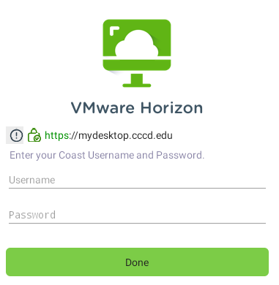

5. For the **Username**, enter your school username (the first part of your school’s email address)

6. For the **Password**, enter your Coast password

6. Click on **Done**

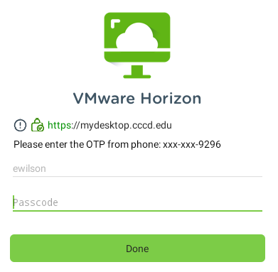

7. Enter your Passcode from the text message received on your phone

**NOTE**: You have 5 minutes to use the OTP before it expires.

8. Click **Done**

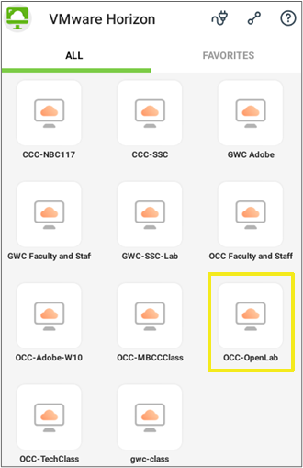

All students, regardless of the college you are attending should select the **OCC-OpenLab** option.

Observe in the center of the screen the Windows “Welcome” messages with progress indicator. Wait for all desktop icons to display.

Locate the icon for **Lockdown Browser** on the Windows desktop.



Execute **Lockdown Browser** (Double-click the icon)

Observe that Lockdown Browser starts and the Canvas sign on page appears.

Login to Canvas as you normally would and navigate to the class and quiz or exam.

**NOTE**: The computer may be noticeably slower when using VM Horizon software. Please be patient.

**NOTE**: When you are done, be sure to use normal Shutdown procedure within the remote desktop environment.